**Lab 4 - Wireframing for Requirements Tutorial**

**Introduction to Wireframing**

Wireframing is a crucial step in software engineering, particularly during the requirements phase. It provides a visual representation of the layout and functionality of a software application, helping to clarify requirements and ensure effective communication among stakeholders.

**Importance of Wireframing**

* **Visual Representation of Requirements**: Clarifies how the software will look and function.
* **Clarifying Functional Requirements**: Defines structure, components, and user flows.
* **Early User Feedback**: Enables rapid feedback to refine requirements.
* **Reducing Ambiguities**: Minimizes misunderstandings with a consistent visual reference.
* **Defining User Experience (UX)**: Ensures usability principles are considered early.
* **Efficient Iteration**: Allows quick problem-solving before development.
* **Supporting Agile Development**: Acts as a visual blueprint for continuous updates.
* **Scope Management**: Defines project scope and aligns team expectations.
* **Improved Communication**: Serves as a common language across teams.
* **Prototyping for Testing**: Enables early testing of system logic and flow.

**Why Wireframing is Preferred**

* **Balance Between Detail and Speed**: Quick yet structured visualization.
* **Focus on User Flow and Functionality**: Prioritizes layout and functionality over aesthetics.
* **Simplifies Communication**: Easily understood by technical and non-technical stakeholders.
* **Easy Iteration**: Can be quickly updated based on feedback.
* **Low Cost**: Cost-effective compared to prototypes.
* **Avoids Design Distractions**: Maintains focus on core functionality.
* **Foundation for Prototyping**: Serves as a base for detailed prototypes.

**Relevance in 2024**

Wireframing remains essential, particularly in early design stages:

* **Agile and Lean Development**: Aligns with rapid iteration and MVP development.
* **Collaborative Tools**: Tools like Figma and Adobe XD facilitate real-time collaboration.
* **Cross-functional Communication**: Simplifies discussions among developers and stakeholders.
* **User-Centric Design**: Validates user flow before high-fidelity design.
* **Cost and Time Efficiency**: Enables quick concept testing and resource savings.

**Basics of Wireframing**

Wireframes visually represent a website/app's structure and user flow, focusing on layout without distractions from color or content.

**Elements of a Wireframe**

* **Logo**: Represents brand identity, typically at the top.
* **Navigation**: Menu or sidebar for exploring the site/app.
* **Search Fields**: Allow users to find specific content.
* **Text Blocks**: Indicate content placement.
* **Buttons**: Actions such as "Submit" or "Buy Now."
* **Image Placeholders**: Define where visuals will be placed.
* **Videos**: Indicate areas for multimedia content.

**Different Types of Wireframes**

1. **Low-fidelity Wireframes**: Basic visuals with simple shapes and placeholder text; useful for early discussions (e.g., hand-drawn sketches).
2. **Mid-fidelity Wireframes**: More precise layouts without detailed visuals; created using tools like Figma.
3. **High-fidelity Wireframes**: Highly detailed, pixel-accurate layouts with actual images and content; used to refine complex ideas.

**Wireframing Tools and Software**

Wireframing tools are vital for mapping user experience and layout. Leading tools include:

1. **Figma**
2. **Mockflow**
3. **Lucidchart**

**How to Create Wireframes: Step-by-Step**

1. **Do Your UX Research**: Understand audience motivations and pain points using user personas and the JTBD framework.
2. **Define Requirements and Prioritize Features**: Involve stakeholders to translate user needs into specific features.
3. **Map the User Flow**: Outline the user’s journey to identify necessary features.
4. **Sketch the Layout and Features**: Create wireframes based on research, considering information architecture and fidelity levels.
5. **Review and Iterate**: Share wireframes for feedback and conduct usability tests.
6. **Build on It**: Transition to detailed mockups and interactive prototypes.

**What is Wireframing in UX?**

Wireframing in UX involves creating a skeletal layout for a digital product, serving as the architectural plan for a website, app, or digital platform.

**Standard Wireframe Sizes**

Different platforms have specific wireframe dimensions:

* **Smartphone Screen**: 1080 px x 1920 px
* **8” Tablet Screen**: 800 px x 1280 px
* **10” Tablet Screen**: 1200 px x 1920 px
* **Desktop Screen**: 768 px x 1366 px

**UX and UI Wireframe Examples**

Every wireframe begins as a basic drawing of your desired layout. Check out the examples below for ideas!

1. **Website Wireframe Sketch**

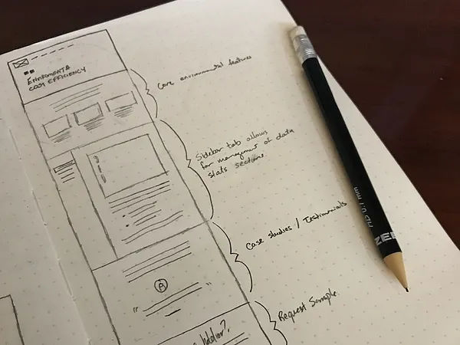

A basic homepage wireframe sketch. It outlines sections and highlights essential details. Simple and straightforward.

**Strengths**

* Allows for quick [ideation](https://www.interaction-design.org/literature/topics/ideation) without tool constraints.
* Encourages collaboration; anyone with a pen can contribute.
* Sparks [creativity](https://www.interaction-design.org/literature/topics/creativity) and is less restrictive than digital tools.

**Weaknesses**

* Not as precise or scalable as digital versions.
* Difficult to share and edit in remote settings.
* Lacks interactivity features present in digital tools.

**Mobile Webpage Sketch**

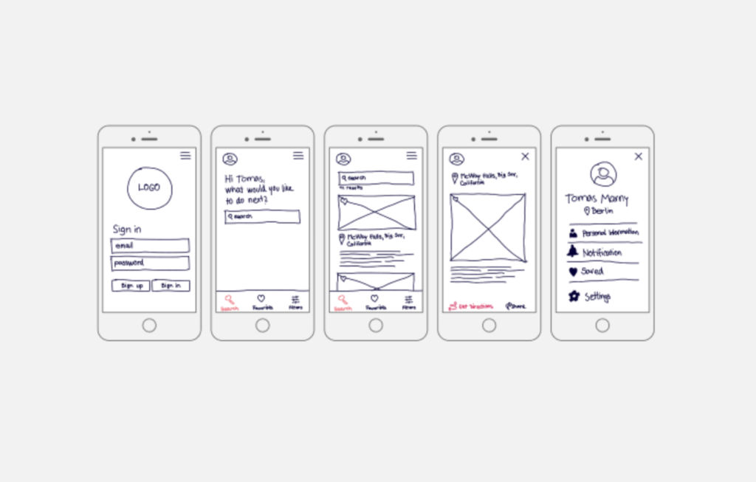

A hand-drawn app wireframe with detail. It gives context for each step and uses grids for structure.

**Strengths**

* Emphasizes the mobile-first approach, focusing on essential features.
* Quick to draft and foster iterative design.

**Weaknesses**

* Limited detailing can lead to assumptions.
* Does not capture specific UI nuances or interactions.
* Not suitable for complex app structures with multiple layers.

**3. eCommerce Mobile Wireframe Sketch**

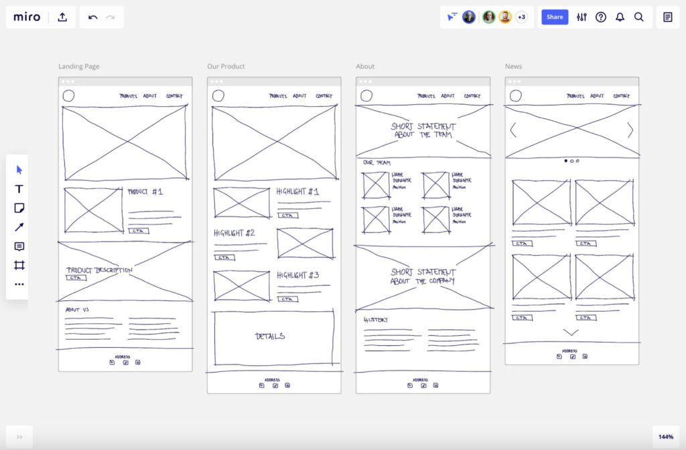

The digital sketch shows the main parts of a mobile eCommerce site. Products are at the top for easier user transactions.

**Strengths**

* Allows designers to quickly visualize product listings, calls to action, and user journeys.
* Encourages a focus on essential eCommerce elements like product images, pricing, and checkout flow.
* Great for brainstorming promotional placements or special features.

**Weaknesses**

* Doesn't capture the detailed intricacies of product variations or filters.
* Limited in representing interactive elements like dropdowns or sliders.
* Often lacks detailed space allocation for promotional content or ads.

As the design matures, transitioning to digital tools can bring more precision and clarity to the wireframes. After sketching out your desired [web design](https://www.interaction-design.org/literature/topics/web-design) layout, progressing to the upper level of digital wireframe refines your design approach.

**4. Classic Blog Website Wireframe**

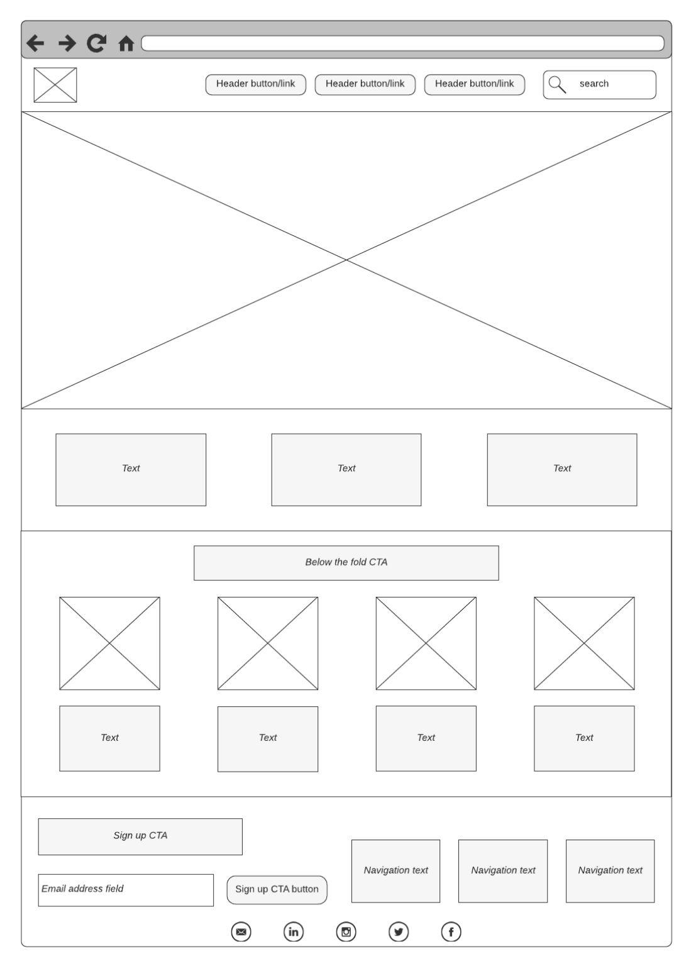

A straightforward digital wireframe example that uses basic tags for description. Empty boxes in the wireframe with crossbars indicate image spots in the UI. This wireframe is ideal for blogs and basic eCommerce sites.

**Strengths**

* Distinct placeholders indicate where images will be for simplified visualization.
* A clear layout supports content-focused designs like blogs and product listings.
* Minimalistic design helps prioritize content hierarchy.

**Weaknesses**

* Lacks intricate design details.
* Interactions and transitions between elements aren't showcased.

**5. Service or Product-Based Website Wireframe**

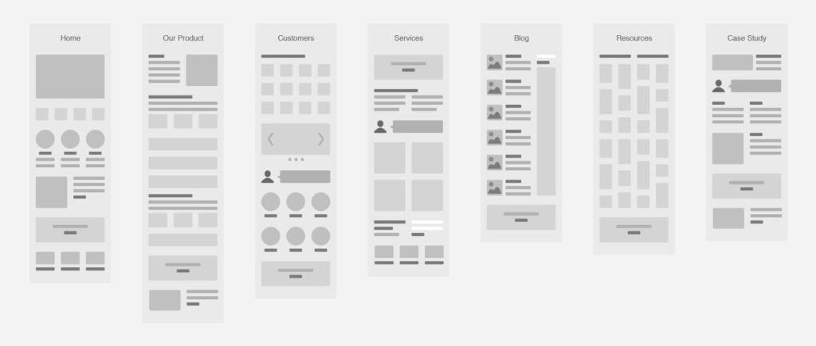

This well-designed example shows diverse page layouts. It includes products, reviews, services, and a blog section in a clear format.

**Strengths**

* A comprehensive design displays varied page layouts.
* Incorporates essential components such as customer reviews and blog posts.
* Offers a holistic view of the site's structure and navigation.

**Weaknesses**

* Absence of color and typography details.
* Does not show potential animations or dynamic content placements.

**6. E-commerce Low Fidelity Mobile Website Pages**

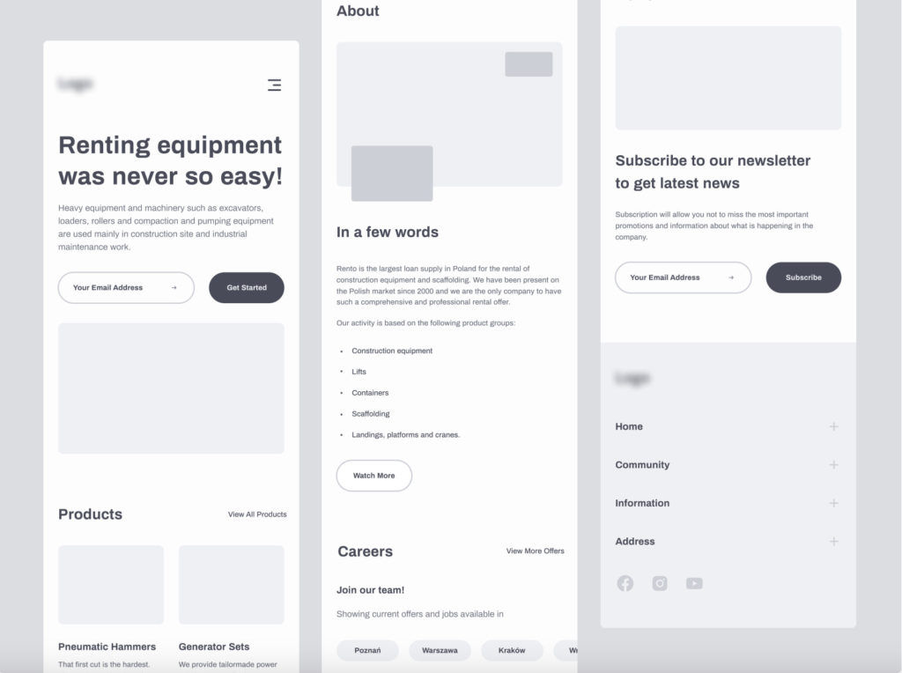

A superb low-fidelity digital wireframe for mobile. It features filled buttons, headings, and text content.

**Strengths**

* Designed specifically for mobile navigation.
* Clear demarcation of buttons, headings, and text.

**Weaknesses**

* Misses out on detailed UI elements like dropdown menus or swiping actions.
* Doesn't represent potential challenges in mobile design, such as limited space.

Finally, we have high fidelity wireframe that bridges the gap between concept and reality. It infuses brand elements such as imagery, typography, and colors. This allows you to visualize your website's final look while ensuring alignment with your brand's identity. Here are three examples of high-fidelity wireframes.

**7. Business Website Wireframe Example**

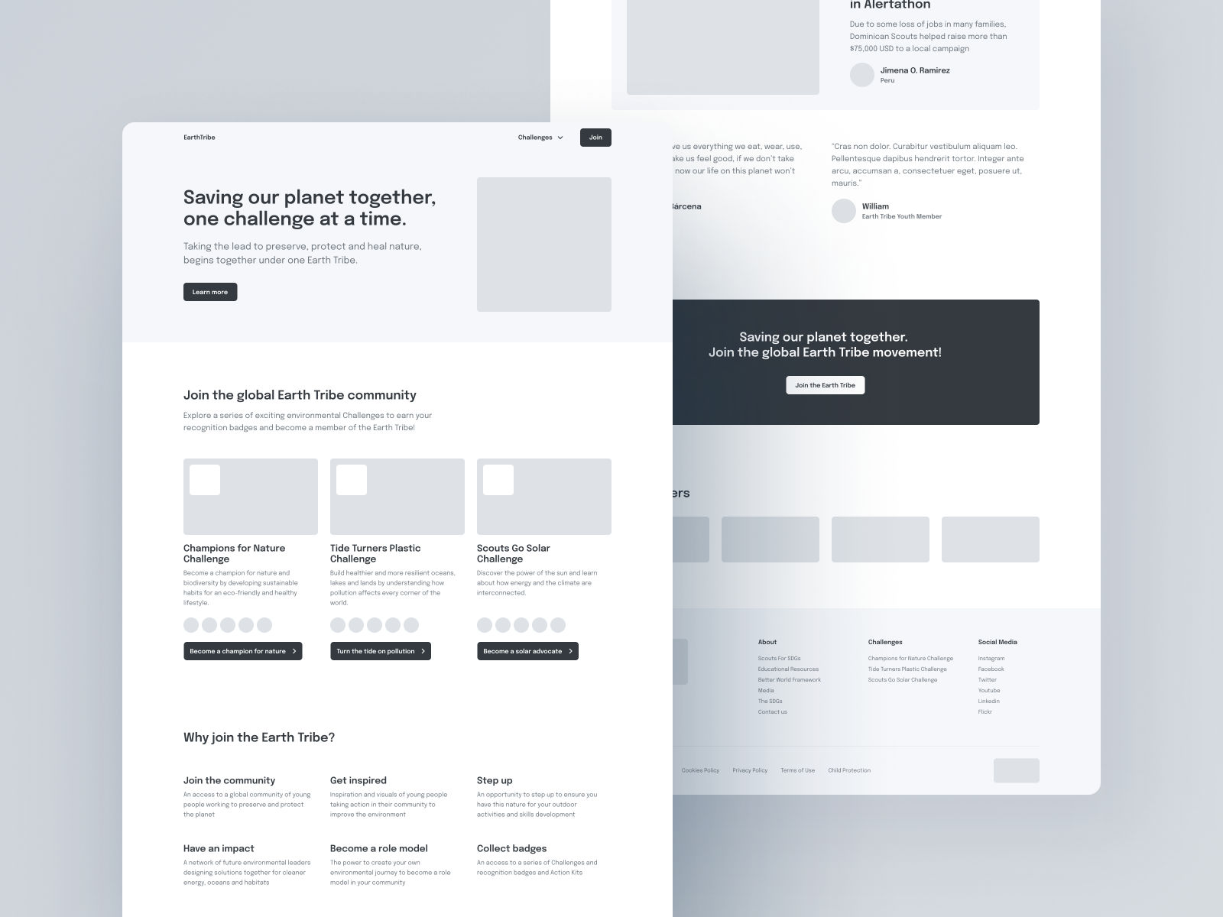

A clear, organized business site wireframe. It includes a header logo, menu, windows, and top-placed call to action for best visibility.

**Strengths**

* A simple, direct layout emphasizes key elements.
* The header logo, menu, and top call to action ensure immediate user engagement.
* A streamlined design facilitates easy navigation.

**Weaknesses**

* May require additional design iterations to optimize for mobile devices (Android and IOS).
* Details about responsive [behavior](https://www.interaction-design.org/literature/topics/user-behavior) or dynamic elements might be lacking

**8. Food Website Wireframe**

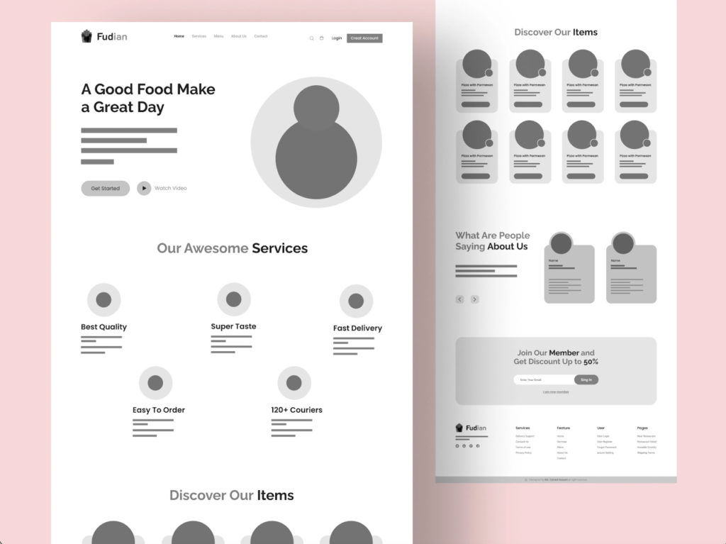

A lively wireframe featuring ample white space and round images. It has a distinct call to action and is user-friendly, and the circular designs add a vibrant touch.

**Strengths**

* A refreshing design with plenty of white space offers an inviting user experience.
* Round images add a playful and contemporary feel, enhancing approachability.
* A clear and prominent call to action ensures user focus.

**Weaknesses**

* Might need additional visual cues or indicators for secondary actions.
* Specifics about image loading and optimization are not evident.

**9. Branded Food Website High Fidelity Wireframe**

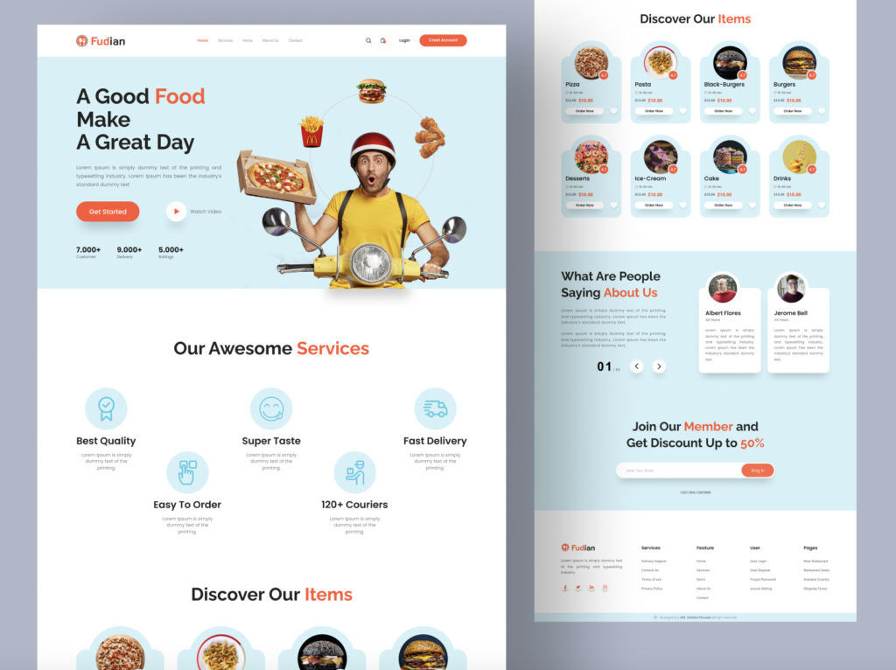

A complete wireframe showcasing text, buttons, colors, and images. It provides a preview of the site's final look before development.

**Strengths**

* Fully detailed with copy, imagery, and design elements; ready for stakeholder review.
* Embraces the brand's colors, imagery, and voice for an authentic feel.
* Comprehensive representation provides a clear vision for developers.

**Weaknesses**

* Might become too cluttered if not optimized for different screen sizes.
* Potential challenges related to font rendering or image resolution may arise.

A detailed vision of high-fidelity wireframes reduces ambiguities during the development phase. It leads to a smoother project flow.

**The Take Away**

As we talked about wireframing in this content, it’s clear that wireframes play an integral role in UX design. You need a clear understanding of elements, types, and appropriate use cases to create better wireframes. You have wireframing tools like Figma, Mockflow, and Lucidchart to support your efforts.

Use the step-by-step guide and wireframe examples as stepping stones toward creating the best wireframes of each type.

Here are the two major takeaways:

Wireframing is a crucial preliminary step in UX design. It helps in the visualization and planning of a product's structure.

The choice of wireframing and prototyping tools can greatly influence the ease and efficiency of the design process. Thus, it’s important to select the right one based on your goals.